**REPORT**



**Experimental Model** **Of Sprocket Gear**

Submitted To

**Engr. Zeeshan Anjum**

Assistant Professor

Department of Mechanical Engineering

**Course: Manufacturing Process**

Submitted By

|  |  |  |
| --- | --- | --- |
| **Sr. No** | **Name** | **Roll No** |
| 01 | Huzaifa Khurshid | FA20-BME-071 |
| 02 | Muhammad Sohail Shazad | FA20-BME-063 |
| 03 | Atif Razaq | FA20-BME-049 |
| 04 | Hammad Bin Khalid | FA20-BME-069 |
| 05 | Sami ul Hassan | FA20-BME-065 |

**OPEN ENDED LAB REPORT**

**STATEMENT:**

Produce a Sprocket Gear using milling machine having maximum diameter of 2.5-inch and number of teeth are 10.

**APPARATUS:**

* Vertical Milling and Drilling Machine
* Compass
* T-Scale
* Protector
* Grinder
* File
* Hacksaw
* Wooden Block

**PROCEDURE:**

The procedure for making sprocket gear is listed below:

1. We started with a wooden block of suitable size and shape. It was rectangular in our case and ensured a smooth and flat surface.
2. We locate the center of the wooden block and mark it clearly.
3. We used a compass to draw a circle with a 2.5-inch diameter around the marked center point. Draw another circle of 3.5-inch diameter which will act as a boundary of our gear.
4. We used a protractor to divide the circle into 10 equal parts by marking points every 36 degrees along the circumference.
5. On each of the marked points, drill holes using an appropriate drill bit size. These holes will serve as reference points for shaping the gear teeth.
6. We used a hacksaw to carefully cut away the extra material around the outer circle, creating a circular gear blank.
7. To create gear teeth, we made a cut into the outer edge of the circular gear blank. Ensure the teeth are evenly spaced and properly shaped.
8. We smoothed the edges and surfaces of the wooden gear, making sure there were no rough edges and splinters left.
9. We cleaned up our final product and it's complete.

**SAFETY PRECAUTIONS:**

1. Always wear appropriate safety gear and follow safety guidelines while operating the milling and drilling machine.
2. Ensure the drilling and milling machine is in good working condition with all safety features operational.
3. Properly clamp or secure the wooden workpiece in place to prevent movement during machining.
4. Use the appropriate cutting tools designed for wood, and ensure they are sharp and in good condition.
5. Adjust the feed rate and depth of cut according to the machine's specifications and the type of wood you're working with to prevent overloading the machine.
6. Keep your hands and clothing away from moving parts, such as the rotating cutter or drill bit.
7. Adhere to the manufacturer's recommendations and guidelines for safe machine operation. Remember that working with machinery always carries risks, so prioritize safety at all times to prevent accidents and injuries. If you're unsure about any aspect of using the drilling and milling machine, seek guidance from an experienced workshop supervisor or instructor.

**OBSERVATIONS:**

**1. WORKPIECE:**

Material = Wood

Dimensions: Maximum Diameter = 2.5-inch

Outer Circle Diameter = 3 inch

Thickness=0.5 inch

Division Angle = 36 Degree

Number Of Teeth = 10

**2. CUTTING TOOL:**

Drill bit is used having diameter of 7.5 mm.

**3. SPEED:**

Speed of Cutting Tool = 800 RPM

**4. MATERIAL:**

Material of cutting tool= HSS

**SCHEMATIC DIAGRAM OF SPROCKET GEAR:**

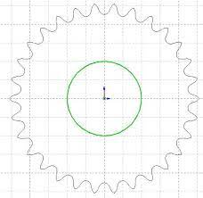

Figure 1: Schematic Diagram of Sprocket Gear

**EXPERIMENTAL MODEL OF SPROCKET GEAR:**

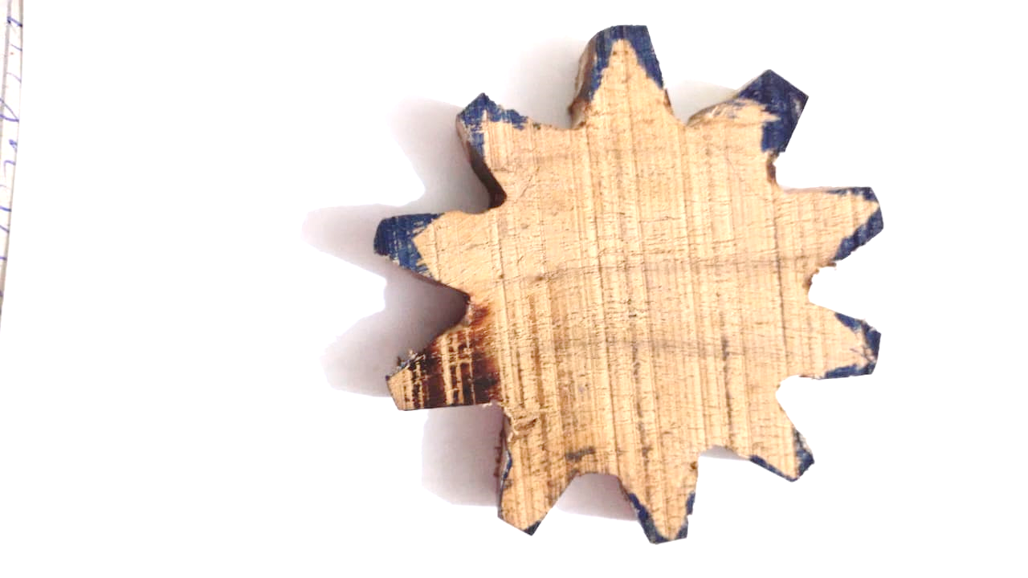

Figure 2: Experimental Model of Sprocket Gear